Matrix Exponentiation

This is very helpful in solving recurrence relations. One of whose examples is
fibonacci numbers.
In matrix exponentiation , we try to find a matrix which can convert k
th state to (k + 1)^{th} state, i.e.
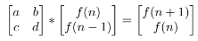
On solving we get a = b = c = 1 and d = 0. Our matrix becomes
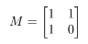
Since by multiplying once we reach on we reach on (n + 1)^{th} state from nth
state. In the same way we reach on (n+k)^{th} state from nth state by multiplying
M matrix k times with our original matrix.

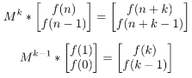

We can compute M^{k−1} in log(k) time. Using these equations this can be done
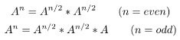

Various helpful Recurrence Relations
Recurrence relations can be solved very easily. We can find the M matrix just
by analyzing.
Various examples are
- f(n) = a*f(n-1) + b*f(n-2)
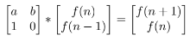

- f(n) = f(n-1) + f(n-2) + c
Here 3 variables are involved , f(n-1) , f(n-2) and c. Therefore our M matrix will be of 3x3.
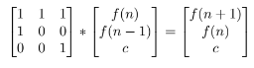

- f(n) = f(n-1) + f(n-3)
This can be further written as f(n) = f(n-1) + 0*f(n-2) + f(n-3). So here also 3 variables are involved, that are, f(n-1) , f(n-2) , f(n-3). Hence a 3x3 matrix will be formed.
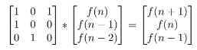

- f(n) = a*f(n-1) + c*f(n-3) + d*f(n-4) + e
This can be written as f(n) = a*f(n-1) + 0*f(n-2) + c*f(n-3) + d*f(n-4) + e Therefore, here 5 variables are involved viz f(n-1) , f(n-2) , f(n-3) , f(n-4) , e. Hence a 5x5 matrix will be formed.
